April 2015

It is without hesitation that I recommend Allison Schott for a teaching position. Allison has served herself well here at Ben Franklin Elementary School. She has become well versed in delivering the programs of envisions for math, reader’s and writer’s workshop, along with social studies and our new science curriculum.
In addition Allison worked in an inclusion setting where she was able show calm and patience with students of various needs. She also worked closely with guidance to seek current interventions to implement during this long term assignment.
In closing, Ms. Schott displayed kindness, diligence, planning, communication, teamwork along with intelligence. She also participated in our reading challenge and door decorating activity to celebrate reading. Ms. Schott will be an asset to your school family.
Sincerely,
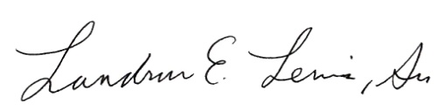
Landrus E. Lewis, Sr.
Principal

